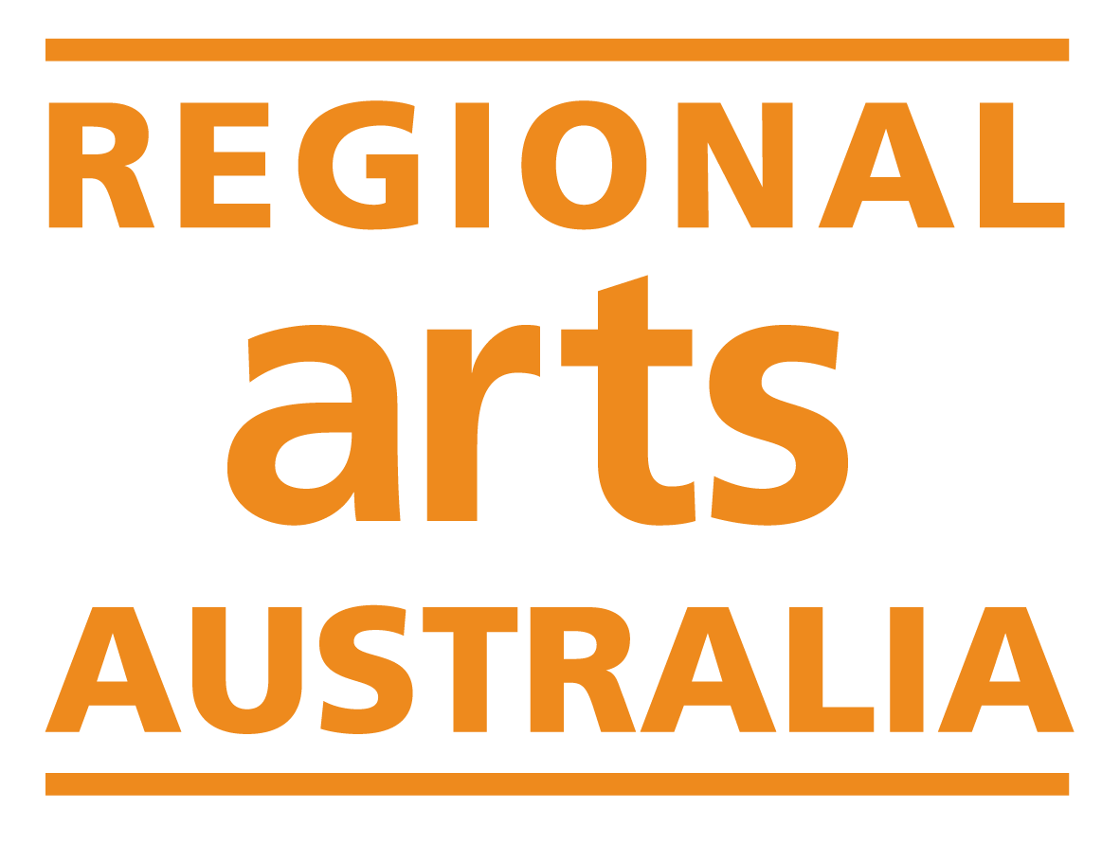

National Regional Arts Fellowship

Program Guidelines 2024

Opening date & time: | 9:00am AEDT, Tuesday 6 February 2024
Closing date & time: | 11:59pm AEDT, Sunday 10 March 2024
Enquiries: | Regional Arts Australia  Grants Manager  rafmanager@regionalarts.com.au  +61 447 204 189
Date guidelines released: | February 2024

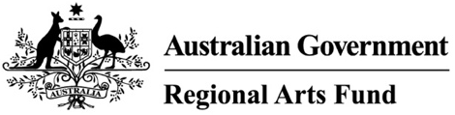

The National Regional Arts Fellowship Program is a strategic project supported by the Regional Arts Fund and delivered by Regional Arts Australia.

Contents
1. Regional Arts Fellowships: Grants Process 4
2. Introduction 5
3. About the National Regional Arts Fellowship Program 5
3.1. Program Objectives 5
4. Funding Available and Funding Period 6
4.1. Fellowships Available 6
4.2. Fellowship Period 6
5. Eligibility Criteria 6
5.1. Applicant Eligibility 7
5.2. Ineligible Applicant Types 7
5.3. Location Eligibility 7
5.4. Eligible Expenditure 7
5.5. Ineligible Expenditure 8
6. Assessment Criteria 8
6.1. Criterion 1: Impact 8
6.2. Criterion 2: Reach 9
6.3. Criterion 3: Support and Partnerships 9
6.4. Criterion 4: Quality and Viability 9
7. How to Apply 10
7.1. Stage One: Expressions of Interest 10
7.2. Stage Two: Expanded Proposal 11
8. Key Dates & Timing 11
9. Assessment Process 12
9.1. Assessment of Applications 12
9.2. Assessment Panels 12
10. Successful Fellowship Applications 13
10.1. The Funding Agreement 13
10.2. Payment 13
10.3. GST 13
10.4. Agreement Variations 13
11. Announcement of Fellowships 14
12. Fellowship Activity Monitoring 14
12.1. Your Responsibilities 14
12.2. Responsibilities of Regional Arts Australia 14
12.3. Reporting 14
12.4. Evaluation 15
13. Acknowledgement 15
14. Probity 15
14.1. Protocols for working with Aboriginal and Torres Strait Islander People and Cultural Materials 15
14.2. Working with Children 16
14.3. Working with Vulnerable People 16
15. Enquiries and feedback 16

Regional Arts Fellowships: Grants Process

Introduction
These guidelines contain information about the National Regional Arts Fellowship Program 2024. You must review these guidelines before filling out an application.
This document sets out:
- The purpose of the grant opportunity.
- The eligibility and assessment criteria.
- How grant applications are considered and selected.
- How grant activities will be monitored and evaluated.
- Responsibilities and expectations in relation to the grant opportunity.

About the National Regional Arts Fellowship Program
The National Regional Arts Fellowship Program is a strategic project supported by the Regional Arts Fund and delivered by Regional Arts Australia. Fellowships provide guaranteed income for regional artists and arts workers to develop work, skills, networks, or research.
The Fellowship Program is an investment in the sustainable development of professional and creative practice in regional and remote Australia.

Program Objectives
The National Regional Arts Fellowship aims to provide guaranteed income for artists/practitioners to build connections, generate exchange, strengthen the national network of regional artists, arts workers and communities, and through doing so:
- Encourage and support sustainable economic, cultural, and environmental careers and/or artistic practices for regional and remote artists and arts workers.
- Support a diversity of artforms, career stages, cultures, and geographies.
- Generate strategic, collaborative relationships for the benefit of arts and creative practice across the regional and remote arts sector.
- Support quality and viability of artistic and cultural activity in regional and remote Australia.

Funding Available and Funding Period

Fellowships Available
Six fellowships will be available in 2024 with a total funding pool of $100,000. At least fifty percent of the fellowships provided will be targeted to cohorts that Regional Arts Australia has identified as being under-funded or under-represented in the Regional Arts Fund competitive grants program. Applicants to the targeted streams will also be automatically considered for the open streams.

Creative & Professional Development
The Creative & Professional Development Fellowship provides $20,000 to regional artists and arts workers to support creative practice or professional development, with a focus on sustainability. In 2024, a total of four Creative & Professional Development Fellowships will be awarded. One will be designated for Aboriginal & Torres Strait Islander applicants, and one will be designated for d/Deaf applicants and/or applicants with lived experience of disability.

Early Career Development
The Early Career Development Fellowship provides $10,000 to regional artists and arts workers who are in the early stages of their practice or career and have had less access to funding opportunities. It supports the development of creative practice or professional development opportunities, with a focus on sustainability. In 2024, two Early Career Development Fellowships will be provided. One will be designated for Aboriginal & Torres Strait Islander applicants.

Fellowship Period
Fellowship activities will run from 1 July 2024 – 30 June 2025 inclusive. The maximum grant period is one year.

Eligibility Criteria
Your application can only be considered if you satisfy all the eligibility criteria. If you are uncertain whether you are eligible to apply, please contact Regional Arts Australia prior to beginning an application.

Applicant Eligibility
To be eligible you must:
- Be an individual with an active Australian Business Number (ABN) that is registered to your name and location. If you are under 18, you must be auspiced by a person over 18 with an active ABN.
- If required by the Australian Tax Office, be registered for the purposes of GST.
- Not have any outstanding reports, acquittals or serious breaches relating to any Australian Government funding. A serious breach is one that has resulted in, or warrants, the termination of a grant agreement.

Ineligible Applicant Types
You are not eligible to apply if you are:
- An organisation, partnership or trust.
- An individual based outside of regional or remote Australia (see Location Eligibility below, section 5.3).
- An employee directly involved in the delivery of the Regional Arts Fund.
- An individual who has already received a National Regional Arts Fellowship within the past five years.
- A current member of Regional Assembly.

Location Eligibility
Your primary address must be in a regional area in order to be eligible for funding. Individuals based in metropolitan locations are not eligible to apply. To determine eligible locations the program uses the Modified Monash Model. To check if you are based in an eligible location, visit the Health Workforce Locator at www.health.gov.au/resources/apps-and-tools/health-workforce-locator and follow the directions below:
- Enter your address into the ‘Address’ box at the left-hand side of the page.
- Tick the box beside ‘Modified Monash Model’, selecting the most recent year.
- Press ‘Search location’.
- All locations with codes from MM 2 to MM 7 are eligible.
The primary address listed here must match the registered address on your ABN. If your ABN is incorrect, you can update it by contacting the Australian Business Register.

Eligible Expenditure
Fellowship funds may be used for the following:
- Fees and wages (all personnel should be appropriately paid).
- Travel and accommodation costs (including international).
- Materials.
- Venue and equipment hire.
- Insurance.
- Administrative and marketing costs.
- Disability access costs.
- Infrastructure costs and the purchase of assets up to $5,000 (this will only be considered where it is demonstrated to be more cost-effective than hire).

Ineligible Expenditure
Fellowship funds may not be used for any of the following:
- Activities that are not primarily focussed toward sustainable creative or professional development.
- Activities principally benefitting a major city or metropolitan location (MM1) as determined by the Modified Monash Model.
- Activities that will commence before funding is approved.
- Components of activities that are also funded by other programs administered by the Australian Government or other state and local government agencies.
- Activities which do not substantially align with and further the objectives of the National Regional Arts Fellowship Program (see Section 3).
- Touring activities from MM1 locations to regional locations.
- Academic activity, including wages or course work that is required as part of any tertiary academic program.
- Competitions, prizes or awards.
- Infrastructure costs and the purchase of assets over $5,000, including building or fitting out permanent structures.

Assessment Criteria
Providing quality information in your application that is clear and concise within the available word limits is essential. All assessment criteria are given equal weighting.

Criterion 1: Impact
Encourage and support sustainable economic, cultural, and environmental careers and/or artistic practices for regional and remote artists and arts workers.
Applicants should demonstrate this through identifying:
- Long term outcomes.
- Demonstrated need for the activity.
- Creation of future opportunities.
- Profile raising of regional artists or arts workers.
- Skills development.
- Opportunity for an artist or arts worker to access an exceptional or rare opportunity.
- Sustainable economic outcomes (e.g. employment, tourism).
- Sustainable cultural outcomes (e.g. health & wellbeing, access).
- Sustainable environmental outcomes (e.g. adapting practice, research, material or equipment upgrades).

Criterion 2: Reach
Support a diversity of artforms, career stages, cultures, and geographies.
Applicants should demonstrate this through identifying:
- Access to creative and professional development opportunities for diverse communities and/or practitioners.
- Opportunities to expand arts practice or participation in the regional and remote arts sector.
- Geographical spread of the activity.

Criterion 3: Support and Partnerships
Generate strategic, collaborative relationships for the benefit of arts and creative practice across the regional and remote arts sector.
Applicants should demonstrate this through identifying:
- Community support and engagement.
- Development of networks, collaborations, and partnerships.
- Benefits to the wider regional and remote arts sector in Australia.

Criterion 4: Quality and Viability
Support quality and viability of artistic and cultural activity in regional and remote Australia.
Applicants should demonstrate this through identifying:
- Experience/calibre of the applicant in the relevant field.
- Strength of outcomes relevant to the scope of the proposed activity.
- Need for funding support.
- Quality and viability of activity plan, timeline, and budget.
- Appropriate remuneration for all personnel.

How to Apply
You must review these guidelines before you apply.
You are responsible for ensuring that your application is complete and accurate. Giving false or misleading information will exclude your application from further consideration. Incomplete applications will be considered ineligible.
Applications will be accepted via an application form, which is available online through SmartyGrants. You will receive an email from SmartyGrants acknowledging receipt of your application once it has been submitted.
If you cannot access the online application form, we will accept applications in other formats including Auslan, audio, video, printed, dictated, electronic and handwritten formats. Please contact the Regional Arts Australia Grant Manager to discuss alternative submission formats.
Please complete each section of the application form and make sure you provide the requested information. The application form has been designed to assist you to demonstrate how your proposal meets the program’s objectives and address the assessment criteria.
The application process is split into two stages: an expression of interest, followed by an expanded proposal for shortlisted applicants.

Stage One: Expressions of Interest
The expression of interest is designed for applicants to pitch a general idea to the assessment panel. Expressions of interest do not need to provide any confirmed partners, activities, or timelines. There is no budget submission. Expressions of interest will be assessed on the impact that the proposed activity will have on the applicants practice or career.
Applicants will be asked to provide the following:
- Response: What do you propose to do? (300 words)
- Response: What impact will this fellowship have on your practice or career? Consider assessment criteria 1, 2 and 3 in your response. (300 words)
- Response: What are your key career or practice achievements to date? (200 words)
- Response: How will you spend the funds? (200 words)
- Alternatively, applicants may choose to provide the above responses as a five-minute audio or video recording.
- Two referees that have agreed to provide a testimonial upon request.
- Supporting material: CV and portfolio of past works (maximum 10 pages combined).

Stage Two: Expanded Proposal
Approximately 25 applicants will be shortlisted and invited to submit a more detailed proposal. Expanded proposals will be assessed on the viability of the proposed project, and will require confirmed partners, a project timeline, and a budget.
Applicants will be asked to provide the following:
- Project Summary (250 words)
- Key Outcomes (250 words)
- Response to the four assessment criteria (250 words each)
- Project Timeline
- Project Partners (with letters of confirmation)
- Budget

Key Dates & Timing
Shortlisted and unsuccessful applicants will be notified in writing approximately four weeks following the closing date of the round. Shortlisted applicants will then have four weeks to develop and submit an expanded proposal. Shortlisted applicants will be notified of the final outcome approximately 8-10 weeks following the closing date of the expanded proposal submission. Projects will commence from 1 July 2024.
Please note that these dates and timeframes may change. Applicants are advised to keep this under consideration when scheduling activities close to the funding period start date.

Assessment Process

Assessment of Applications
Each application is assessed against the eligibility criteria listed in Section 5. Eligible applications are then assessed on their merits against the assessment criteria (see Section 6) and against other applications, through an open competitive grant process. An application is assessed on its merits, based on:
- How well it meets the criteria.
- How it compares to other applications.
- Whether is provides value with relevant money.
When assessing the extent to which the application represents value with relevant money, the panel will have regard to:
- The overall objective/s to be achieved in providing the grant.
- The alignment of the geographic location of the application with the identified priorities
- The demonstration of the evidence in the application contributing to the outcomes/objectives of the grant opportunity.

Assessment Panels
Regional Arts Australia will assess the applications against the eligibility criteria. External assessors appointed by Regional Arts Australia will assess the eligible applications for shortlisting and will then assess the expanded proposals for final selection.
Applications to the Aboriginal and Torres Strait Islander applicant stream will be assessed by at least one Aboriginal and/or Torres Strait Islander assessor. Applications to the stream for d/Deaf applicants and/or applicants with disability, will be assessed by at least one individual with lived experience of d/Deafness and/or disability.
To protect the integrity of the assessment process, it will not be possible to request the names of individual assessors who assessed your application.

Successful Fellowship Applications

The Funding Agreement
Successful applicants will be required to enter into a legally binding grant agreement with the Regional Arts Australia. Standard terms and conditions for the grant agreement will apply and cannot be changed.
A schedule may be used to outline the specific grant requirements. Any additional conditions attached to the grant will be negotiated with the successful applicant and outlined in the schedule to the grant agreement.

Payment
The grant agreement will state the grant amount to be paid and the manner of payment. The amount is final. You will be required to meet additional costs, should they be incurred. The grant agreement will include an agreed payment schedule. Payments will be made against this schedule following execution of the grant agreement and on provision of a correctly rendered tax invoice.

GST
Payments will be made as set out in the agreement. Payments will be GST inclusive, where the applicant is registered for GST. Additional information regarding GST can be found on the Australian Taxation Office website at www.ato.gov.au.

Agreement Variations
It is recognised that unexpected events may affect the progress of an activity. If you experience any delays or are unable to spend your funds in accordance with your grant agreement for any reason, you must notify Regional Arts Australia as early as possible to request a variation.
You can request a grant agreement variation to:
- Adjust activity milestones.
- Extend the timeframe for a reasonable period of time to allow completion of the activity make minor changes to grant activities (only for unforeseeable events).
- Make changes to activity personnel.
- Change allocations across approved budget line items (if over 10% of the total grant – budget reallocations to approved budget lines under 10% of the total grant do not require formal approval).
If you wish to propose changes to the grant agreement, you must complete a Request for Variation form via SmartyGrants. Contact Regional Arts Australia for further information.
You should not assume that a variation request will be successful. Your request will be considered based on factors such as:
- How it affects the activity outcome.
- Whether it is consistent with the program objectives and any relevant Australian Government policies.

Announcement of Fellowships
If your application for a Fellowship is successful, your grant will be listed on the Regional Arts Australia's website and in media materials announcing the grants. The Australian Government Minister responsible for the arts has the option to announce Fellowship recipients.

Fellowship Activity Monitoring

Your Responsibilities
You are responsible for meeting the terms and conditions of the grant agreement and managing the activity efficiently and effectively. You are also required to comply with record keeping, reporting and acquittal requirements as set out in the grant agreement.

Responsibilities of Regional Arts Australia
Regional Arts Australia will:
- Meet its responsibilities in relation to the terms and conditions set out in your grant agreement.
- Provide timely administration of the grant.
- Evaluate the grantee's performance by assessing the acquittal report provided by the grantee.

Reporting
Grantees are required to submit a final acquittal report within 40 business days of the completion of the Fellowship, unless otherwise state in your grant agreement. You are expected to report on your Fellowship activity’s achievements against agreed objectives including:
- Progress against agreed key deliverables
- Outcomes of the activity
- Outcomes of partnerships and collaborations
- Expenditure of grant funding against agreed budget
- Evidence of acknowledgement of funding
- At least two high quality photos and/or some video of the activity.

Evaluation
Regional Arts Australia will evaluate the National Regional Arts Fellowship program from time to time to measure how well the outcomes and objectives are being achieved. The evaluation will identify and document the impact of activities and may also include a survey of individuals which have received funding.

Acknowledgement
You will be required to identify and maximise opportunities to promote the Australian Government contribution to the activity, including through print media, social media, and other forms of electronic media. The Regional Arts Fund logo and Regional Arts Australia logo must be used on published materials related to Fellowship activities.

Probity
Regional Arts Australia will make sure that the grant opportunity process is fair, according to the published guidelines, incorporates appropriate safeguards against fraud, unlawful activities and other inappropriate conduct and is consistent with the Commonwealth Grant Rules and Guidelines.

Protocols for working with Aboriginal and Torres Strait Islander People and Cultural Materials
Fellowship activities that involve Aboriginal and/ or Torres Strait Islander people or cultural content must comply with the Australia Council’s Protocols for Using First Nations Cultural and Intellectual Property in the Arts: https://creative.gov.au/investment-and-development/protocols-and-resources/protocols-for-using-first-nations-cultural-and-intellectual-property-in-the-arts
Applicants will be asked to provide supporting information about how they will engage appropriately with Aboriginal and Torres Strait Islander people and/or cultural content.

Working with Children
Fellowship activities that involve working with children must provide evidence that all personnel have current Working with Children Checks. Children means any individual under the age of 18 years. In addition, the Fellowship recipient must provide evidence that they have undertaken training in the National Child Safety Principles, prior to funding being awarded.

Working with Vulnerable People
Vulnerable Person means an individual aged 18 years and above who is or may be unable to take care of themselves or is unable to protect themselves against harm or exploitation for any reason, including age, physical or mental illness, trauma or disability, pregnancy, the influence, or past or existing use, of alcohol, drugs or substances or any other reason.
Fellowship recipients working with vulnerable people must provide a Category 37 Australian Federal Police check for each person that will be working with vulnerable people over the course of the activity. These checks must be received prior to funding being awarded.

Enquiries and feedback
Enquiries about the grant process can be made to Regional Arts Australia through the following avenues:
- Email: rafmanager@regionalarts.com.au
- Phone: +61 447 204 189
- Mail: PO Box 5287, Wagga Wagga Bc NSW 2650
It is expected that all communications between applicants, potential applicants and Regional Arts Australia are professional. Where this is not the case from any party, this may result in the termination of communications.

